ETM (Engineering Test Mode) – CGEA 1.3

Functional Description

Engineering Test Mode (ETM) is a level of operation within the cluster that is intended to be used by its engineering and service activities. It is not intended to be used by the customer.

ETM is a series of display screens that display data used by the cluster.

Interfaces

Interface Context Diagram (I/O Block Diagram)
Figure 1 ETM (Engineering Test Mode) Context Diagram
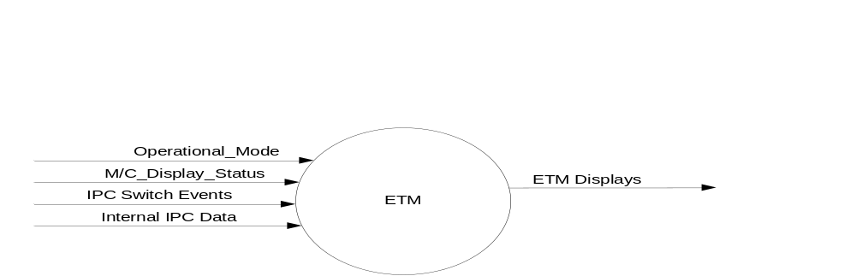

Inputs

- INTERNAL:
- Operational_Mode
- IPC Switch Events
- M/C_Display_Status
- Internal IPC Data

Outputs
- ETM Displays

Function/Performance

Operational Modes

Mode | Differentiating Vehicle Conditions
Sleep Mode | ETM Off
Limiting Mode | ETM Off
Normal Mode | ETM Off/On
Crank Mode | ETM Off/On

Voltage Levels

Refer to the Cluster Features table located in the Operational Modes and Voltage Range Strategies Section in this SPSS.

Human-Machine Interface

Visual

Indicator Graphics / Display Format

Indicator Color Coordinates

Reference section COLOR & ILLUMINATION REQUIREMENTS (GRAPHICS) and the ETM Text file.

Indicator Characteristics

Refer to Message Center _SHMI Displays_ 5 Button Interface Section

Audio

None

Switch Control Logic

Consumer access to the Display Unit Selection Control Configuration shall be as specified in the message center basic functionality display as specified in Message Center _SHMI Displays_ 5 Button Interface Section.

System Accuracy

Within a 100msec of receiving a message that results in a change of state the cluster will update the display to the proper status.

Operation: Performance and Functional

Subsystem Algorithm Flowchart / State Diagram

Operational Description (supports algorithm flowchart /state diagram)

ETM is set to FALSE at Battery Connect and Operational_Mode = Limited and Operational_Mode = Sleep

For one-area-display IPC, ETM is set to TRUE when the IPC Message Center OK Switch is pressed and held for the first 5 seconds of Operational_Mode = Normal. A one-area-display IPC is a cluster whose display is designed to display Driver Information Features, such as Gauges, Message Center and RTTs. The IPC Message Center OK Switch is the OK Switch that controls the DI Features. Typically, this is the input in SteWhlCtl_LSide_OK signal.

For one-area-display IPC, ETM is set to FALSE when the IPC Message Center OK Switch is pressed and held for the first 8 seconds of Operational_Mode = Normal.

For two-area-display IPC, ETM is set to TRUE when the IPC Message Center OK Switch is pressed and held for the first 5 seconds of Operational_Mode = Normal. A two-area-display IPC is a cluster whose display is designed to display both Driver Information Features, such as Gauges, Message Center and RTTs, and MyTouch Features, such as Phone, Navigation and Audio. The IPC Message Center OK Switch is the OK Switch that controls the DI Features. Typically, this is the input in SteWhlCtl_LSide_OK signal.

For two-area-display IPC, ETM is set to FALSE when the IPC Message Center OK Switch is pressed and held for the first 8 seconds of Operational_Mode = Normal

For one-area-display IPC, ETM is set to FALSE when ETM is TRUE and an ETM Screen is the current Display and the IPC Message Center OK Switch is pressed and held for 3 seconds in Operational_Mode = Normal

For two-area-display IPC, ETM is set to FALSE when ETM is TRUE and an ETM Screen is the current Display and the IPC Message Center OK Switch is pressed and held for 3 seconds in Operational_Mode = Normal

For one-area-display IPC, the ETM Screen is displayed in a box in the same location of the display as a Driver Information Warning would be displayed.

For one-area-display IPC, all warnings must be RESET before an ETM Screen is displayed.

For two-area-display IPC, the ETM Screen is displayed in the area for the MyTouch Features in a box over the top of what would normally be on the display. The MyTouch Features display continues to update while the ETM Screen is a top layer over it. Typically, the MyTouch Features are on the RHS display of a two display IPC or on the RHS of a large single display that was area for both DI and MyTouch Features.

For one-area-display IPC and two-area-display IPC, when ETM = TRUE, the letters “ET” shall be treated as a General RTT and will be displayed in the General RTT Bank.

A Down Arrow Press event on the Message Center Switch while an ETM Screen other than ET420 (AFE_Bias_Factor Screen) is the current Display will cycle to the ETM Screen with the next higher numbered Message ID unless the current is the ETM Screen with the highest numbered Message ID in which case the ET100 becomes the new ETM Screen to be displayed.

An Up Arrow Press event on the Message Center Switch Set while an ETM Screen other than ET420 (AFE_Bias_Factor Screen) is the current Display will cycle to the ETM Screen with the next lower numbered Message ID unless the current is ET100 in which case the ETM Screen with the highest numbered Message ID becomes the new ETM Screen to be displayed.

A Left Arrow Press event on the Message Center Switch Set while an ETM Screen is the current Display will result in no action.

For one-area-display IPC, an IPC Message Center Right Arrow Switch Press while an ETM Screen is the current Display will result in the Message Center Main Menu Screen becoming the new screen to be displayed.

For one-area-display IPC, an IPC Message Center Left Arrow Switch Press while ETM = True and the Message Center Main Menu Screen is the current display AND Display_Language_MC IS NOT EQUAL to Arabic will result in the display of ET100.

For one-area-display IPC, an IPC Message Center Right Arrow Switch Press while ETM = True and the Message Center Main Menu Screen is the current display AND Display_Language_MC IS EQUAL to Arabic will result in the display of ET100.

For two-area-display IPC, an IPC Message Center Right Arrow Switch Press while an ETM Screen is the current Display will result in the MyTouch Home Screen becoming the new screen to be displayed.

For two-area-display IPC, an IPC Message Center Left Arrow Switch Press while ETM = True and the MyTouch Home Screen is the current display AND the LHS Main Screen is the current display AND Display_Language_MC IS NOT EQUAL to Arabic will result in the display of ET100.

For two-area-display IPC, an IPC Message Center Right Arrow Switch Press while ETM = True and the MyTouch Home Screen is the current display AND the LHS Main Screen is the current display AND Display_Language_MC IS EQUAL to Arabic will result in the display of ET100

The required ETM Screen Display information is identified in the “ETM Text” file. All of this information must be included in the ETM screen flow. The “ETM Text” file also contains the recommended sequence and display format. ETM Screen ET420A is not included in the sequence and can only be displayed via an OK press while displaying ET420. Additional screens can be added to the ETM sequence with the approval of the DI Application Engineer. Each IPC program must create a program specific “ETM Text” if it uses a different ETM Sequence or ETM screen format than specified in the recommended “ETM Text” file.

All ETM screens can be in English regardless of the active language as per Display_Language_MC.

The ETM feature must be functioning in both pre-production and production source code. This feature shall be in production source code unless a waiver is obtained from the DI Application Engineer.

Function Safety Classification (EMC)

Class B

Memory Storage

Parameter Name | Description | Value at  Battery Connect | Value at Module Wake-up
Internal IPC Data | Numerous variables that are used by the IPC software. | See appropriate Section for each variable. | See appropriate Section for each variable.
ETM | State indicator for Engineering Test Mode | False | False
M/C_Display_Status | State Indicator to identify which text is currently being displayed on Message Center display. | See Message Center SHMI Section | See Message Center SHMI Section
IPC Switch Events | Events that are indicated as per the switch interface for the Message Center. | See MC Switch Section | See MC Switch Section
ETM Displays | Display content for the ETM screens and their associated ETM sequence number. | See ETM Text file. | See ETM Text File.
ETM_Pointer | The ETM sequence number of the ETM Display that will be displayed if ETM = True and the display scheduler needs to display an ETM Display | ET100 | ET100
Operational_Mode | 4 state indicator for cluster operational mode | Limited | Limited, Normal or Crank

Reconfigurable Telltale

“ET”

Prove Out

Not applicable

Message Center Msg

Refer to ETM Text Section of this SPSS.

Error Handling

None

Diagnostics

Self Test

None

Engineering Test Mode

This Section defines ETM

Part II Performance

None

Reference Specification

ETM Text File

Revision History
SPSS Module Revision History

Revision Level | Name | Change Description | Date
1.0 | T. Cwik | Initial Release | 11/17/2013
2.0 | T. Cwik | Added “other than ET420 (AFE_Bias_Factor Scrren)” to 1.3.5.2.15 and 1.3.5.2.17  Rewrote 1.3.5.2.16 and 1.3.5.2.18 | 1/16/2014
2.1 | T. Cwik | Added “AND the LHS Main Screen is the current display” to 1.3.5.2.18.1 and 1.3.5.2.18.2. | 1/29/2014
2.2 | T. Cwik | Updated 1.3.5.2.16 and 1.3.5.2.18 by moving the NOT from the .2 requirement to the .1 requirement | 2/4/2014
3.0 | T. Cwik | Updated to achieve a common approach for the AFE Bias Factor Update with the non-M3 IPC.  1.3.5.2.12 – Added “other than ET420A (AFE_Bias_Factor Screen)”.  1.3.5.2.13 – Added “other than ET420A (AFE_Bias_Factor Screen)”.  1.3.5.2.15 – Removed “other than ET420 (AFE_Bias_Factor Screen)”.  1.3.5.2.17 – Removed “other than ET420 (AFE_Bias_Factor Screen)”.  1.3.5.2.19 – Added “ETM Screen ET420A …”. | 8/21/2014

